

Artful Inspirations

2015 Gift Pack



* Images on cover may vary from images in package

What better way to stay in touch with your list than to send them a daily bit of inspiration to warm their soul.

There are many daily motivation services, but none like Artful Inspirations. Artful inspirations are a unique blend of hand-picked quotes, images and success tips that are designed to be a list growing and keep-in-touch tool that will not only be welcomed, but anticipated in your client and prospects email boxes.

Many people enjoy short, simple doses of inspiration every day making this a sure fire way to stay in touch with your list in a meaningful way. This is also a powerful list building tool because motivation is very viral, which means that people forward inspirational and humorous messages to their friends, family and colleagues more than anything else.
We hope that you are using this product as part of a relationship-based, multi-touch marketing strategy that includes other Ready2Go Marketing Solutions’ (our other company) products as well as your own products.
Artful Inspirations are a great lead magnet – that special offer that begins the relationship with your client. From your numerous marketing activities (we provide 10 suggested activities in this package), prospects will access your Artful Inspirations in a variety of ways which will grow your list, nurture relationships, and convert more clients.
When your prospect signs up for Artful Inspirations, they have given you permission to continue communication with them if you provide meaningful, content rich information. By doing this, you are on your way to converting qualified prospects to paying clients. Remember, it takes time for familiarity to grow, for trust to be developed and for your prospect to learn how you can solve their needs.
Maintaining persistent and consistent communication on a regular basis is not easy. And that is why we developed this creative, artful, inspiring way to make meaningful contact with your clients and prospects. A relationship based, multi-touch marketing strategy is the most effective way to stay in touch and deliver value all year round!
Here’s to your enjoyment and success!


Kim Clausen, President
Ready2Go Marketing Solutions, Inc.

If you like these Artful Inspirations, consider purchasing the other packages to use as a list & relationship building tool.
Here’s what you get with the
Artful Inspirations Packages:
- 8 beautifully crafted photos and inspirational quotes in jpeg format that your prospects and clients will love to receive! You can use them in a variety of ways to grow your list and deliver great value.
- 8 coordinating Success Tips (150-350 word ‘mini articles’) that are professionally written and designed to coordinate with your Artful Inspirations.
- 10 tips on how to use Artful Inspirations in your business
- Instructions on how to set up your Artful Inspirations daily (or weekly) motivator
And a SPECIAL BONUS!
- Promotional copy that you can email or use as an advertisement

- Registration page copy so you can easily create your sign up page
This is another $375 value for free!
To see the other Artful Inspirations packages, go to http://ready2gomarketingsolutions.com/artful-inspirations-packages.html
And while you’re there, you can check out the more than 100+ other readymade, ready2go products that you customize and brand as your own, such as:
- Special Reports
- Audio Training Programs
- Speeches
- Teleseminars
- Workshops
- Success Tips
- Tweets
And when you order ANY PRODUCT,
take 25% off by entering promo code PROMOAI25.
Enjoy your Artful Inspirations!

Published by Artful Inspirations.

Copyright © 2012-2015 by Artful Inspirations (a product of Ready2Go Marketing Solutions, Inc.
All rights reserved. No part of this publication may be reproduced or transmitted in any form or by any means, electronic or mechanical, including photocopy, recording, or any information storage and retrieval system now known or to be invented, without permission in writing from the publisher, except by a reviewer who wishes to quote brief passages in connection with a review written for inclusion in a magazine, newspaper or broadcast.
"This publication is designed to provide accurate and authoritative information in regard to the subject matter covered. It is sold with the understanding that the publisher is not engaged in rendering professional service of any kind. If expert assistance is required, the services of a competent professional person should be sought."
DISCLAIMER
This publication is sold with the understanding that neither the author nor the publisher is engaged in rendering professional services. Questions relevant to the specific professional needs of the reader should be addressed to practicing members of those professions.
The information, ideas, and suggestions contained herein have been developed from sources, including publications and research, which are considered and believed to be reliable, but cannot be guaranteed. Moreover, because of the technical nature of the material and the fact that laws are never static, but ever changing, the assistance of a competent, qualified professional is recommended when implementing any plans or ideas discussed in this publication, in whatever medium the material in this publication is used.
The publisher specifically disclaims any liability, loss, or risk, personal or otherwise, incurred as a consequence directly or indirectly of the use and application of any of the techniques or contents of this publication.
This publication and the contents herein are provided without any warranty, express or implied, as to their effect, completeness, or results received.
TERMS OF USE
By purchasing or using this publication and the contents herein, you agree that they may only be used for your personal use and may not be sold or redistributed without the written consent of Ready2Go Marketing Solutions, Inc. The publisher of this package has no way of knowing the specific needs of the reader. It is necessary then that you understand the limitations of this or any other package.
LICENSE
This publication is copyrighted. The buyer of this publication is given a limited license to use its contents for his or her use.
This package and all its contents are sold to you, the buyer, with the agreement that your purchase entitles you to a non-exclusive right to use this package and the material contained herein for personal educational use.

Printed in the United States of America

Table of Contents

About Artful Inspirations 7
10 Tips for Using Artful Inspirations in Your Business 9
How to Implement Your Artful Inspirations 11
Inspirational Images and success tips 13

About Artful Inspirations

About Artful Inspirations

Artful Inspirations is a way to provide inspiration to those who find that motivational quotes and pictures are the perfect remedy to warm their soul.
Kim Clausen is the Founder of Artful Inspirations a division of Ready2Go Marketing Solutions, a company that creates completely developed workshops, teleseminars, speeches and more that personal development professionals can brand as their own to grow their business.
Kim is a professionally trained coach who has more than 20 years of marketing and business development experience. She has founded several businesses and has developed a successful coaching practice of her own. Check us out at www.Ready2GoMarketingSolutions.com.
We Have Common Bonds
Like you, we know how difficult it is to continuously grow your database of prospects and clients and stay in touch on a persistent and consistent basis making meaningful contact. We have struggled with the lack of marketing materials to grow our own businesses, and were frustrated by the choices, the availability and the accessibility of quality marketing plans and materials that actually work.
So we did something about it. We went out and crafted these creative and beautiful Artful Inspirations. Artful inspirations are a unique blend of hand-picked quotes and pictures that are designed to be a powerful list growing and keep-in-touch tool that will not only be welcomed, but anticipated in your client and prospects email boxes.

Many people enjoy short, simple doses of inspiration every day making this a sure fire way to stay in touch with your list in a meaningful way. This is also a powerful list building tool because motivation is very viral, as people forward inspirational and humorous messages to their friends, family and colleagues more than anything else.
We are professional marketers, training developers, copywriters, and speech writers who are poised to provide you with the highest quality products and services to grow your business.
And our Artful Inspirations packages are easy to implement, GUARANTEED.
For further assistance, contact us at Support@Ready2GoMarketingSolutions.com or give us a call anytime.

10 Tips for Using Artful Inspirations in Your Business

10 Tips for Using Artful Inspirations in Your Business
- Place it in a highly visible location on your website as a way to grow your list. Artful Inspirations are an effective lead magnet – a giveaway that attracts prospects to your site that they receive in exchange for their contact information. Once you have driven people to your website through different mediums, they will opt in to receive their daily quotes, and you can then begin to nurture a relationship with someone who has already expressed an interest in your products and services.

- Add the image to the signature line of your email with an invitation and link to sign up for free. Change it regularly to attract attention. You probably email hundreds of people each week. Make sure everybody in your network knows what you have to offer, and Artful Inspirations are a compelling giveaway that everyone will love. This technique is one of the simplest yet most effective ways to grow your list.

- Send to your list as a daily keep in touch tool. Send a few to your list with an invitation for them to subscribe. If you are offering this daily, do not start sending it to your list every day without them opting in. Instead send a few at a time or once a week making the offer for them to sign up to receive it daily.

- Every time you send an Artful Inspiration, have the sign up link in the email. Encourage others to pass it on.

- Post an ad on websites where your target market frequents with an Artful Inspiration and an offer to sign up for free.

- Research if your target market has any industry organizations or associations and if they have a newsletter. Ask if you can contribute Artful Inspirations to their newsletter.

- Put Artful Inspirations on note cards and postcards to communicate with your clients and prospects.

- Add a motivational thought to your newsletter with an invitation to subscribe to the daily service.

- Use Artful Inspirations in your web site design.
- Use Artful Inspirations in your correspondence and other products.

How to Implement Your Artful Inspirations

Your Artful Inspirations are Easy to Implement
When you receive your Artful Inspirations, you receive a JPEG image which can easily be embedded into websites and emails, etc. You use Artful Inspirations just as you would any other image or photo that you place in an email, document, electronic newsletter, or on your website.

Additionally, your Artful Inspirations come with a professionally crafted Success Tip (a 150-350 word ‘mini article’).

Send them together or separate as a way to deliver valuable content that your clients and prospects will anticipate and enjoy.
Artful Inspirations as a daily or weekly motivator:

If you have a list management and email service such as Aweber, Constant Contact or 1Shopping Cart, Mail Chimp or Infusionsoft, you can set up your Artful Inspirations to be emailed to your subscribers every day using the autoresponder feature. It is recommended that you pre-load them every week or up to 1 month at a time (depending on the capability of your service provider) and schedule their delivery. Some services allow you to simply upload a photo, while other services require some minor html coding which can easily be done by a qualified V.A. who has basic web skills. The requirements vary with each service.

Inspirational Images

And Success Tips

Your Real Goals


Goals are important. Everyone knows this. That’s why there are goal-setting retreats, workshops, seminars and journals. If you never pick a point on the horizon, how do you know which direction to walk?

However, most people’s goals aren’t really their goals. Many people set goals in reaction to the responsibilities, expectations and demands they face in their life. Maybe your goal is to make six figures this year, but you are motivated to make that money because you have bills to pay and mouths to feed. Maybe your goal is to finish writing your book, but it’s not because you care about the book…you just want the approval of those who’ve said, “Hey, you should write a book!”
Maybe you are striving to get that advanced degree, but it’s only to satisfy the prodding of your parents.

Real goals are the ones that YOU actually care about. They light you up, give you energy and make you feel excited. Real goals have nothing to do with expectation or obligation, and everything to do with what matters most to YOU.

Of course, we’re bombarded every day with expectation and obligation. We have to react to a constant barrage of requests, demands and last-minute emergencies. And when those are handled, it’s time to rest so we can get up and do it all again tomorrow.

My friend, it’s time to break the cycle. It’s time to dream.

In order to get in touch with the things that will make your life amazing, you need to take quiet time to reflect on and listen to what it is you REALLY want.

Leaving your family and responsibilities for a long weekend to venture into the woods for a journey of self-exploration may not be feasible. But you can start with a simple “sit-down”. A “sit-down” is a five-minute meditation followed by 20 minutes of journaling. Ask yourself, “What do I really want?” The real answers will feel thrilling. Write them down. Circle the most exciting ones, put realistic deadlines next to them, and create your action plan.

Often our dreams feel far away, impossible to achieve, or unreachable for a variety of reasons we’ve made up in our minds, or others have told us. But MANY goals are achievable when we think them through, plan them out in simple steps, and consistently allocate time to them.

Life is too short to spend it chasing someone else’s goals or dismissing your own because someone else said it’s not possible. Don’t’ wait another moment - pursue your real goals today.
Mastering Your Motivation

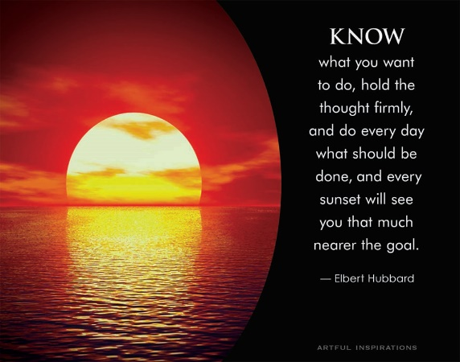
Reaching our personal and professional dreams depends entirely upon our ability to motivate ourselves. We can have all the talent and resources in the world but without self-motivation we won’t get very far.

So what can you do to ensure your motivation stays in peak form?

Try implementing these critical skills into your own life to master your motivation.

Risk management. Does the idea of taking risks inspire you to take action or weaken your resolve? Tackling the right risks has as much to do with self-confidence as it does with the actual risk itself. Take small risks to build your confidence. You’ll learn when it’s best to take action and when to take a step back.

Accepting constructive feedback. No one likes criticism; it can shake our confidence and leave our motivation waning. But when we train ourselves to listen for the constructive feedback, even if it’s not presented in a constructive way, we give ourselves an opportunity to grow and get stronger. What helpful messages can you gain from the insights of others?

Dealing with setbacks. Overcoming obstacles to keep our drive alive requires resilience. In the movie The African Queen, both Humphrey Bogart and Katherine Hepburn’s characters must navigate a treacherous river to reach their final destination and confront dangerous killers. En route they overcome enemy gunfire, dangerous rapids, hunger and illness, as well as facing their own, and each other’s shortcomings only to end up giving up on their goal, unaware it’s just around the next bend. Are setbacks making you quit before you reach your goal? Dig deep and find your strength - your success may be just around the next bend.

Setting high, but achievable goals. We either tend to set goals that are too ambitious or not ambitious enough. Think like ‘Goldilocks’ and find the goal that’s ‘just right’ – a goal that pushes you just enough to keep yourself engaged and motivated, but not too big that it feels impossible and discourages you from even trying.

By developing your self-motivation skills you’ll begin to notice increased productivity, and efficiency, and you will experience more happiness in your life.

Incorporating even one of these new skills into your daily routine means you too can keep your self-motivation high and get to work on finding more success and fulfilling your dreams!
Your Confidence Tune-Up

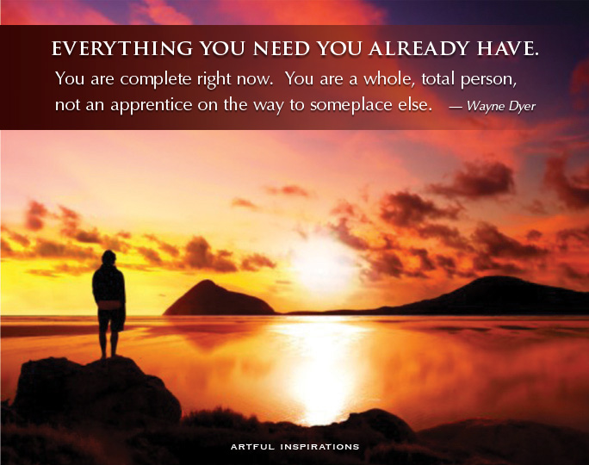
Whether you’re stepping into the boardroom or simply stepping into your day, confidence is the key to feeling great, performing your best, living a great life, and inspiring others to do the same.

But it’s not always easy to find your swagger and keep that pep in your step, is it? Especially if you’ve recently encountered obstacles, losses or challenges that may have knocked you off track.

Fortunately, we humans are surprisingly simple creatures. As such, we respond well to triggers and cues, especially when it comes to shifting our mindset.

To that end, here are a few quick confidence boosters for you to use any time your confidence needs a boost.

They work. I promise.

- Sit Up Straight
Your mom was right, good posture is important. But it’s just not a matter of keeping a hunchback at bay…when you sit or stand tall, you feel better. Slumping or slouching inhibits your breath, slows the function of your organs, and makes you feel cruddy. Good posture on the other hand, helps more oxygen flow to your lungs, eliminates body aches, and just plain ‘ole feels better.

And try this – today when you talk on the phone, stand instead of sit. Stand tall, walk around, and notice the renewed power and confidence in your voice.

- Throw Your Hands Up
In many cultures winning is usually followed by hands thrust into the sky in a wide V. It’s a natural physical reaction. Who knows which came first, but there’s a direct correlation between throwing your hands in the air and feeling like a winner. Behavioral scientists have identified this posture as “The Power Stance.” Try it right now to get a boost. Hold it for 1 minute and you’ll be unstoppable for the rest of the day.

- Pump Up the Jams
Cultures all around the world have ritualistic and ceremonial dances. Sports stars plug in their favorite music before the big game. Professional speakers and entertainers play their ‘pump up’ tunes before they go onstage.

Music has a profound ability to physiology shift your mood, so put together a playlist of your favorite tunes and listen to it daily. Add in some movement for an even greater impact on your overall well-being. And for an even greater boost, sing your favorite songs loud and proud. You might get a few funny looks from the ones you love, but so what. Perhaps they’ll join in too!

- Speak Positivity into Your Day
As you are getting ready for work, making breakfast, or driving in the car, speak out loud and with conviction of how good you feel, how much you are going to accomplish, how you are going to make a difference for others, and how you will show love for your friends, family and colleagues. Speak as if you are a coach in the locker room giving yourself a pep talk to go out and win the game.

Whatever you do, get out there and let the world know who you are. It’s time.

How will you step into your confidence today?

